Festival for Arabian Horses
B Á B O L N A
16.-17. May

INFORMATION

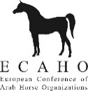
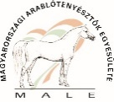
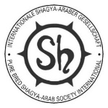
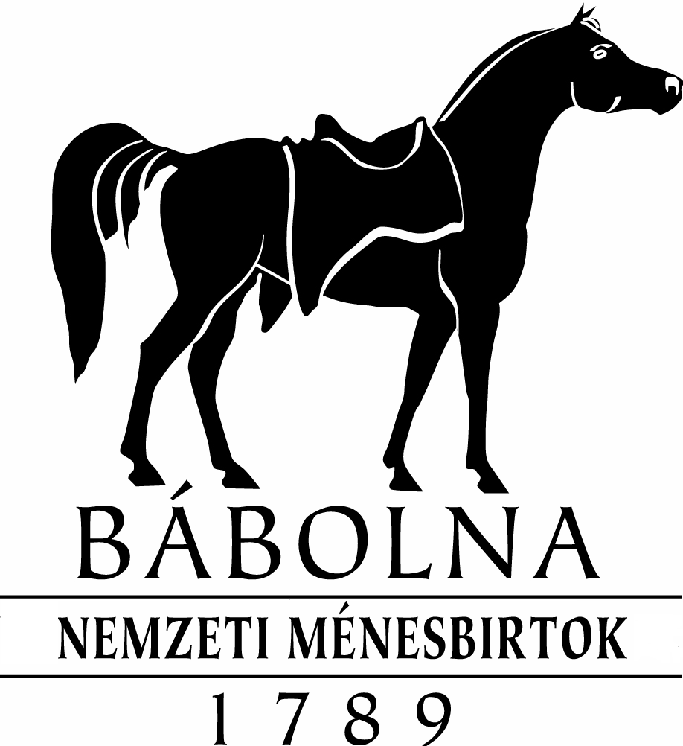
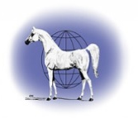
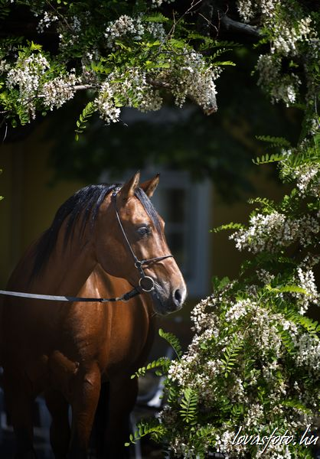
Photo: Hajdú Krisztina

SHOW INFORMATION

BÁBOLNA, 16.-17. May 2026.

INTERNATIONAL SHOW AND SPORT EVENTS

ECAHO „C” International Show
and National Championship for Purebred Arabians

and
ISG European Championships for Shagya-Arabians.

Closing date of entries: 15th April 2026.

Organizers:

Bábolna Nemzeti Ménesbirtok
Bábolna National Stud
2943 Bábolna, Mészáros u.1.
www.babolnamenes.hu

Magyarországi Arablótenyésztők Egyesülete (MALE)
Society of the Hungarian Arabian-Horse Breeders
Tel.: (+36) 34 222 555
(+36) 20 9369836 (Mob.)
e-mail: info@arablo.hu
www.arablo.hu

Main Sponsor:

Bábolna Nemzeti Ménesbirtok
Bábolna National Stud

Eligibility to participate

All Purebred Arabians or Shagya-Arabian horses that are registered in the studbook of the Society of the Hungarian Arabian Horse Breeders, have a pedigree and are owned by one of its members are eligible to participate. In the case of Purebred Arabians from abroad, the horse must be registered in a studbook recognized by the WAHO. For Shagya-Arabians, registered by the International Shagya-Arab Society (ISG - Internationale Shagya-Araber Gesellschaft), which at the time of entry are registered in the studbook of a breeders' association recognized by the ISG in accordance with the ISG Master Studbook and have been proven by a pedigree check based on DNA testing, are eligible.
The stallions must be eligible for registration in Studbook I and registered in it.

Horses may be entered for the show:
Purebred Arabians OX
Shagya-Arabians Sh

Fundamental principles
The show organized for the Purebred Arabians is registered by the EAHSC (European Arab Horse Show Commission) and is conducted according to the EAHSC Show Rules. Horses placed 1-3 in this show are eligible to participate in All National Cup, European, Middle Eastern and World Championships.

Classes:

- Yearling fillies (born in 2025)
- Yearling colts (born in 2025)
- 2 years old fillies (born in 2024)
- 2 years old colts (born in 2024)
- 3 years old fillies (born in 2023)
- 3 years old colts (born in 2023)
- Mares 4-6 years old (born between 2020-2022)
- Stallions 4-6 years old (born between 2020-2022)
- Mares 7-10 years old (born between 2016-2019)
- Stallions 7-10 years old (born between 2016-2019)
- Mares 11 years and older (born in 2015, or before)
- Stallions 11 years and older (born in 2015, or before)

Judging method for the Purebred Arabians:
According to the ECAHO judging method, three judges score in open method from 1 to 20 points, rising by half a point, according to five criteria: type, head and neck, body, legs and movement, and rank the classes by scoring.

Rules for ex aequo in qualifying ranks

If two horses have reached the same score (ex aequo) in the qualification at a class, there are two methods of making a decision:

(A) the horses with the same scores shall be placed one beside the other. The judges declare their preference in writing, without talking to each other. The horse with the most first preferences will get the better rank. Should a horse get a better placement at the same number of judges and there is still a tie, the case will be solved by method B).

B) The horse with the highest score for type will be awarded at the better rank. If there is still an ex aequo, the horse with the highest score for movements will get the better rank. If still no decision can be made, a judge will be chosen by drawing and he must call his preference.

Judging method in the Championships:

All horses that have achieved one of the first three places in their class are eligible to participate in the Championship. The judges will judge independently of each other.
The participants do not arrive for judging in the order of their placement, first, the judges and the audience can see the finalists once again in trot, then in walk they will be lined up in the ring, where the judges mark gold, silver, bronze, and the 4th-placed participant as a reserve on their judging sheets. The evaluators then calculate the scores and announce the results. The following titles can be awarded in the Championship:
Junior- gold, silver, bronze Champion filly
1-3-5. classes
Junior- gold, silver, bronze Champion colt
2-4-6. classes
Senior- gold, silver, bronze Champion Mare
7-9-11. classes
Senior- gold, silver, bronze Champion Stallion
8-10-12. classes

Championships will be conducted according to the EAHSC rules
(www. ECAHO.org

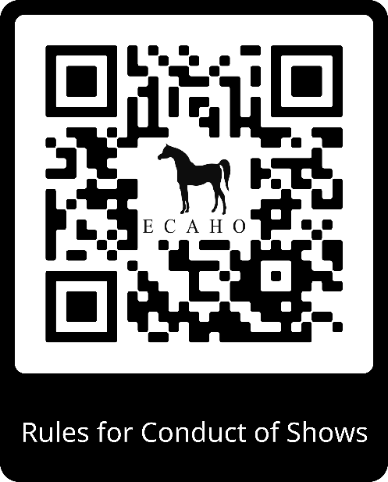

Judging method for Shagya-Arabians:
The judging system is as follows: for each horse, the type, head, neck, body, legs, walking and trotting are scored according to 7 criteria, with a total score of 1-10 points.
The sum of the points is divided by the number of criteria (7) and the number of judges (5). The result is the score of the horse, which is used to determine the ranking.

Rules for ex aequo in qualifying ranks

If two horses have reached the same score (ex aequo) in the qualification at a class, there are two methods of making a decision:

(A) the horses with the same scores shall be placed one beside the other. The judges declare their preference in writing, without talking to each other. The horse with the most first preferences will get the better rank. Should a horse get a better placement at the same number of judges and there is still a tie, the case will be solved by method B).

B) The horse with the highest score for type will be awarded at the better rank. If there is still an ex aequo, the horse with the highest score for movements will get the better rank. If still no decision can be made, a judge will be chosen by drawing and he must call his preference.

Point scale:
10 outstanding 5 sufficient
9 very good 4 insufficient
8 good 3 rather bad
7 pretty good 2 bad
6 satisfactory 1 very bad

Championships:

The first, second and third placed horses in each class are eligible to compete in the Championship. Judging for the Championship will be the same process as described for the Purebred Arabians.

Trophies and ribbons:
Ribbons will be awarded to all participants in the breeding and sport classes. The class winners receive a trophy, the second and third placed horses receive ribbons. A show blanket and a neck ribbon will be awarded to the Gold Champions, a neck ribbon to the Silver and Bronze Champions.

Planned program:
(The schedule may change depending on the number of entries!)

16. May 2026, Saturday

At the riding arena:

- Junior classes for Purebred Arabians
- Junior classes for Shagya-Arabians
- Junior Championships
- Meanwhile, stallion parade, presentation of breeding stallions by tribes.

17. May 2026, Sunday

At the riding arena:

- Senior classes for Purebred Arabians
- Senior classes for Shagya-Arabians
- Senior Championships,
- Meanwhile, stallion parade, presentation of breeding stallions by tribes.

Judges:

For Purebred Arabians:
Ahmed Al Sammaraie (D)
Burchardt Schröder (D))
Kovács Judit (H)
Sabine Marchand Furrer (F)

Purebred Arabians are judged by three judges.

For Shagya-Arabians:
Ahmed Al Samarraie (D)
Burchard Schröder (D)
Michal Horny (SK)
dr. Németh Csaba (H)
Kovács Judit (H)
Sabine Marchand Furrer (F)

Shagya-Arabians are judged by five judges per class. The composition of the jury varies from class to class.

Disciplinary Committee (DC):
Bányai Dóra (HU)
Dr Kulik Mónika (HU)
Dr Kummer Luca Laura (HU)
Dr. Herczog Anna (HU)

Veterinarian:
Dr. Horváth Daniella (HU)
Ringmaster:
Horváth Balázs (HU)

Speaker:
Rombauer Tamás (HU)
Győrffy Villám András (HU)
in English:
Wodala János (HU))
Computer evaluation:
Info-Horse Bt, Bolevácz Gábor (HU)
Bolevácz Elisabeth (HU)
Vargáné Ivacs Andrea (HU)

Responsible Organizer:
Rombauer Tamás (HU)
Chairman, MALE

General regulations & show rules:

- The event is governed by the EAHSC rules for the Purebred Arabians and for the Shagya-Arabians. These rules can be downloaded from the ECAHO website www.ecaho.org. Participants are subject to the judges' decision, which is limited to the event of the breed show and is made by the judges on the basis of the scoring system set out in the rules. The decision of the judges cannot be challenged. The judges are chosen by the organizer and do not act as members of the breeding organization.

- Animal health conditions for the participation:
- Valid horse passport, in which the veterinarian has certified the following examinations and vaccinations:
- Negative test result for equine infectious anemia (EIA) within the last year,
- Negative test results for malleus within the last 3 years
- All horses must be free from infectious diseases and may only come from disease-free herds.
- Influenza vaccinations: All vaccinations must be certified by a veterinarian who is not the owner of the horse.
- The basic vaccination consists of two influenza injections administered at least 21 days and no more than 92 days apart. The first booster shot should be administered within 7 months after the second injection of the basic vaccination.
- The interval between booster vaccinations and the previous vaccination shall not exceed 365 days. The last vaccination shall be given at least 7 days prior to arrival at the show place.
- Upon arrival at the competition, the horse's vaccination must not be older than 6 months, but there is a +21 day grace period. Otherwise, the relevant animal health regulations apply to temporary importation and set-up.
- Three days prior to arrival at the event and while the horses are at the event venue, the rectal temperature of the horses must be measured at least twice a day and recorded by the owner in the FEI HorseApp. Any changes in the horse's health must be reported immediately.
- If all conditions are met, the horse can be unloaded.
- Participants will not be reimbursed for transport costs.
- Entry deadline: 15. April 2026.
- We cannot accept late entries. Entries can only be submitted on the application forms sent out, or copies thereof, accompanied by the horse's passport or pedigree certificate and diagram, as well as a copy of the vaccination certificate.
- Entry fee per horse per class:20.000,-HUF.
For MALE members per horse per class: 5.000.-HUF.
Box fee / day: 7.000.- HUF. (including straw, but hay should be paid separately on the scene in HUF by cash.)

- Entry forms should be sent to the following e-mail address:
info@arablo.hu, or by postal address to: MALE, 2943 Bábolna, Pf. 29.

Entry fees should be transferred to the following K&H Bank account:
- Account owner: MALE, Bábolna
- Account No: 10403356-33500416-00000000
- IBAN: HU17 1040 3356 3350 0416 0000 0000
- SWIFT / BIC: OKHBHUHB
- Please indicate the name of the horse/s AND the invoice recipient in the reference field of the bank transfer.
- Participation is only possible if the corresponding entry fee and box fee have been paid in advance by bank transfer before the deadline. The organizer reserves the right to limit the number of participants for the whole program, to reject participants without giving reasons, and, in special circumstances or in cases of force majeure, take the necessary measures to postpone or cancel the event.
- The organizer accepts no responsibility for any accidents, illnesses, or other damages that may occur to persons or animals. The organizer accepts no liability towards third parties for theft, property damage, or liability damages.
- The organizer reserves the right to merge, divide, or omit certain classes. Classes with fewer than 20 horses will not be divided.
- Entry and box fees will not be refunded less than two weeks before the show.
- The organizer will issue start numbers for a deposit fee, which will be refunded to the owner after the start number is returned.
- All horses, including foals, must be presented in hand.
- We ask that the handlers appear in appropriate attire, which should not feature any emblems, markings, or text referring to the owner or breeder.
- Stallions aged three years and older should be presented with a bit, if possible. If a horse breaks free during the show due to a mistake made by the handler, a penalty of EUR 50 will be imposed, and in extreme cases, the horse may be disqualified. The DC will decide on this.
- A doctor, veterinarian, and a farrier will be available throughout the event. The cost of materials used will be charged to the participant.
- Straw will be provided for the horses.
Hay and feed (oats) or wood shavings for bedding can be requested from the stable manager at the specified time and place for a fee.

Bábolna, 27th of February 2026.

Rombauer Tamás Haál Gábor
MALE Bábolna National Stud
Chairman & Breeding leader Stud Manager

